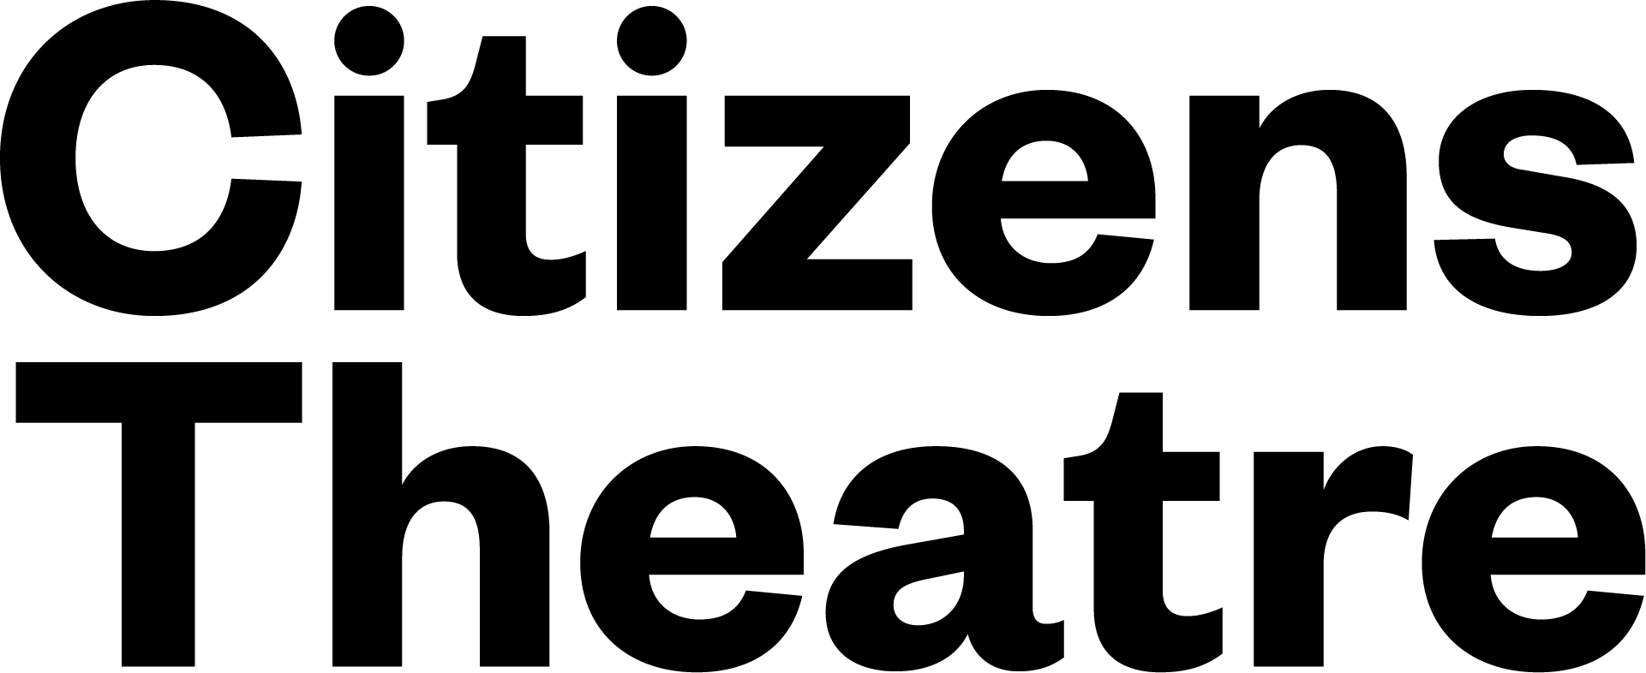

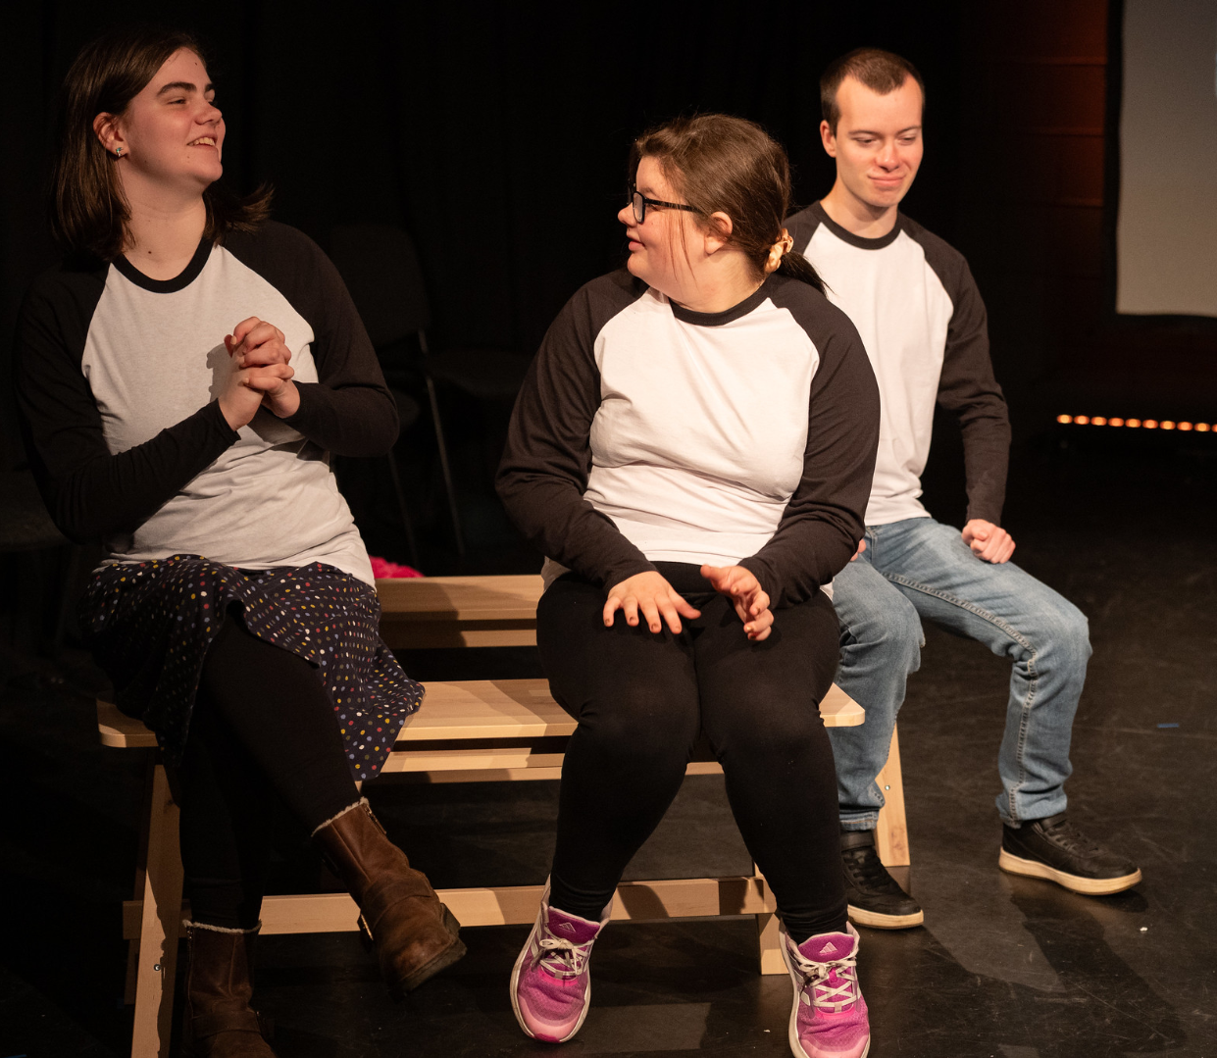

**What to expect at**

**Young Makers**

Hello,

We are very excited that you are thinking about joining our Young Makers class! The class used to be called ‘Saturday Citizens’.

This document will give you some more information about what to expect when you come to Young Makers.

Young Makers is a drama class for teenagers who are learning-disabled or neurodivergent.

(This can include being Autistic, ADHD, dyslexic, dyspraxic, epileptic, having GDD, OCD, Downs Syndrome and/or other conditions).

The staff at Young Makers have lots of experience in making drama spaces positive spaces for neurodivergent young people to learn and have fun.

**Who are the teachers at Young Makers?**

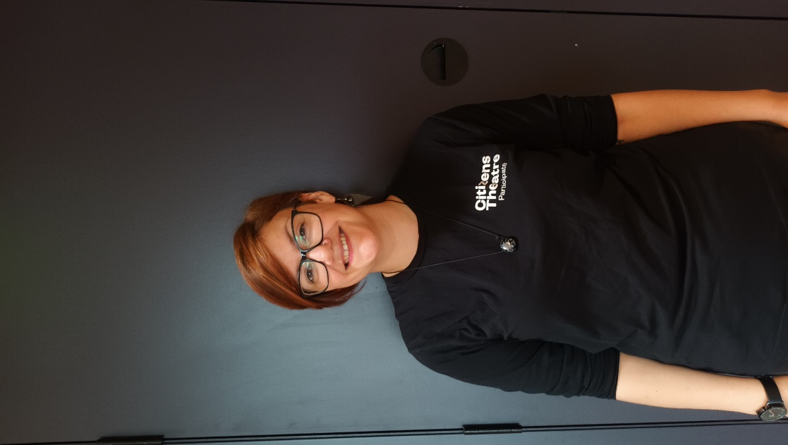This is Morna.

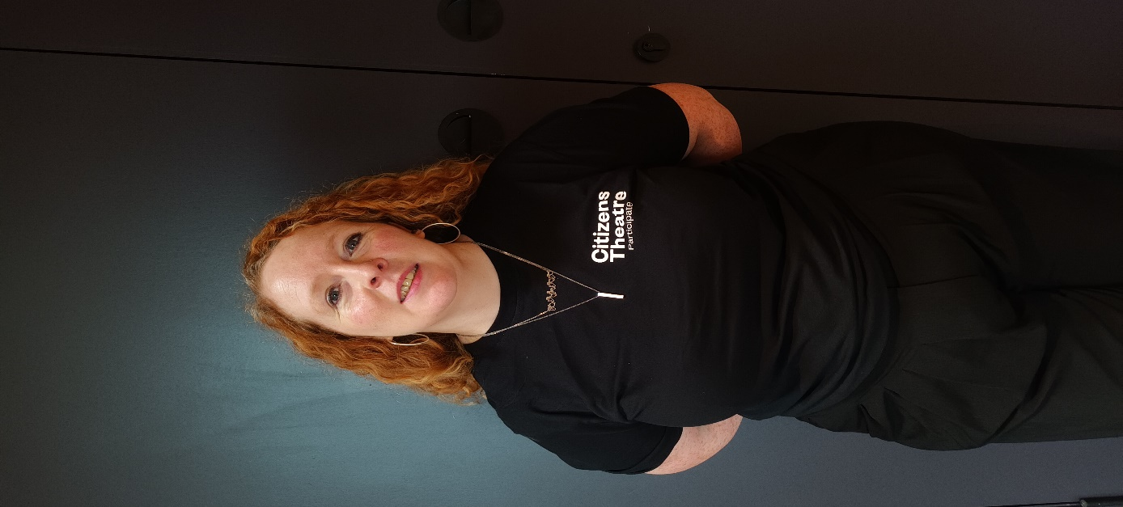And this is Suzie.

Morna and Suzie lead the Young Makers classes.

**When is Young Makers?**

Class starts at **2.30pm** and finishes at **4.30pm** on **Saturdays**.

Classes happen in ‘terms’, like at school. These terms are normally 8 or 10 weeks.

**Each June, we have a chance to share our drama work with family and friends.**

**Where does Young Makers take place?**

At the Citizens Theatre in Glasgow.

The address is **119 Gorbals Street, Glasgow, G5 9DS**

The outside of the building looks like this.

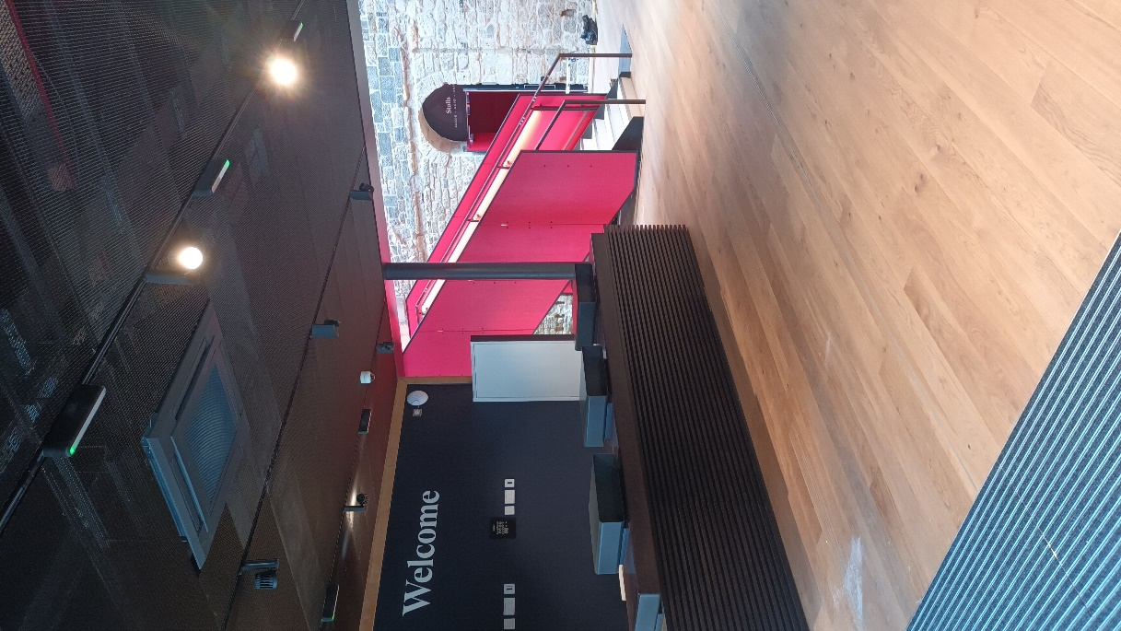

Once you enter the building, you will see the Welcome desk, and the staircase.

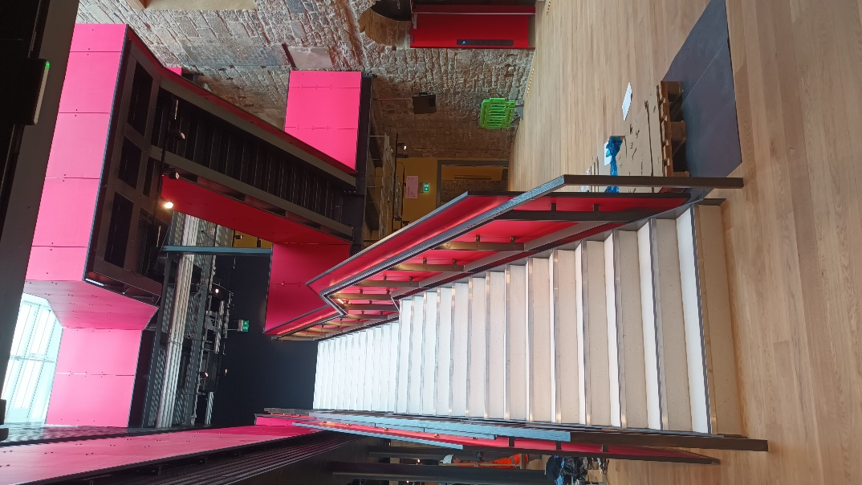Our class takes place upstairs on the first floor.

There is also a lift.

Turning left when you arrive at the top of the stairs, you enter the Circle Foyer.

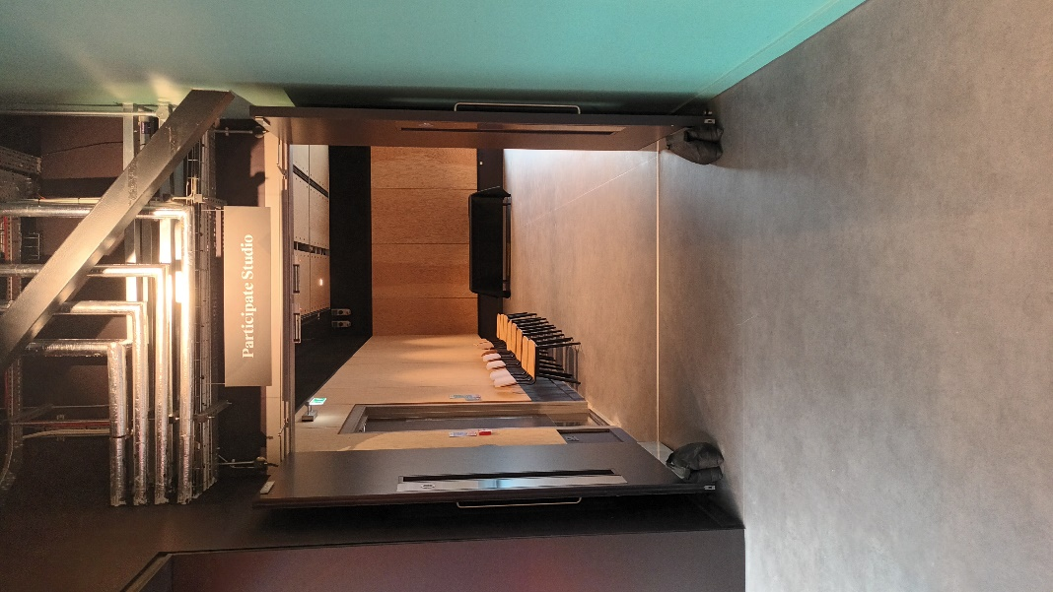

Continue to walk beside the stairs and you arrive at the Participate Studio.

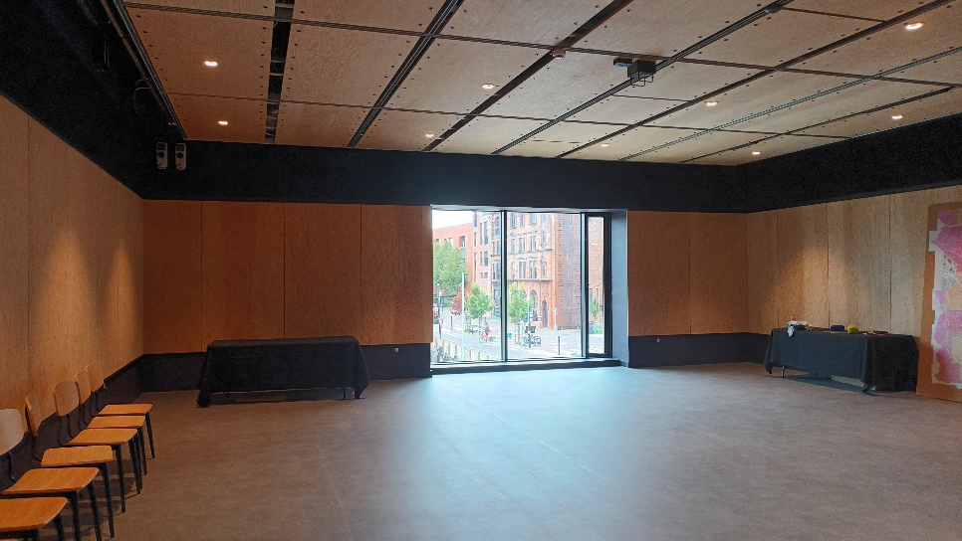

The class always takes place in the Participate Studio.

**What happens at Young Makers?**

Young Makers only has **3 rules**:

1. **Be kind**
2. **Stay safe**
3. **Have fun!**

Class **starts** with everyone sitting on chairs in a **circle**.

Each person tells the group about something **good** that has happened in their week.

We call this: **‘highlights’**.

We then do some **games** and exercises to **warm up our bodies**, to **warm up our voices** and to **warm up our brains** for drama.

If you ever feel like you want or need to sit out, that is always ok.

At **3.15pm** we take a 15 minute **break**.

You can bring a **snack** if you’d like.

You can talk to people during this break, or you can have some alone time.

We often **play music** quietly during the break.

This is a good time to go to the **toilet** if you need to.

At **3.30pm** the group starts again.

We play a **game** to get focused, then we do some **drama** activities.

**Drama** activities could be making up a story together, or it could be acting out a story together.

We always **end** our class in a **circle**, saying what we liked about the class or how we feel about the class.

Then everyone leaves the class at **4.30pm**.