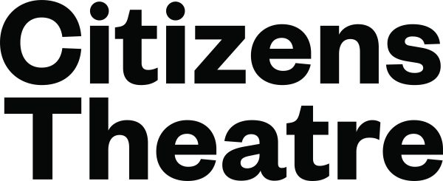

PRESS RELEASE FOR IMMEDIATE USE | TUESDAY 19 MAY 2026

Citizens Theatre invites communities to Assemble this June

- Assemble is a festival of participatory activity inviting communities to create together from 6 to 20 June.
- The festival will take over all spaces of the Citizens Theatre building with a vibrant mix of drop-in and bookable activities involving performance, storytelling and visual art alongside heritage tours and workshops.
- The first week focuses on work developed over the past year through the theatre’s Participate programme while the second week celebrates community connections coinciding with Refugee Festival Scotland.
- Highlights include Project 21, celebrating 21 years of the Citizens Theatre’s Young Company; Theatre lab workshops offering one-off deep dives into different aspects of theatre-making; multilingual heritage tours; and the Big Drama Drop-in hosted by the Community Collective as part of Refugee Festival Scotland.
- Building on the legacy of the theatre’s Homecoming Festival in August 2025, this is the first Assemble festival which will return annually

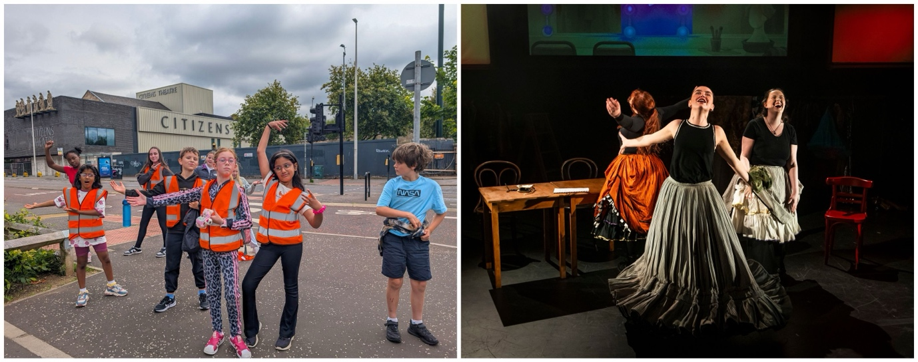
L-R: credit Amber Keating, credit Eoin Carey

IMAGES HERE: https://premiercomms.sharepoint.com/:f:/s/PremierScotlandClients/IgDuQPJtIgtvTo0zVpXZDi_NAbNFZRuB4SdDJD4WL9Yfgho?e=pgBYUH

The Citizens Theatre is proud to announce Assemble, a new two-week festival taking place this June, shaped by and for communities across Glasgow. Assemble celebrates the theatre’s intergenerational and multicultural audiences through performance and activities across the building - inviting everyone to gather, create and belong.
Catrin Evans, Participate Director, said:
“The Citizens Theatre lives and breathes because of the people who are part of it. We have been blown away by the response and engagement from communities since we re-opened. We see every day how theatre and creativity open up spaces for shared stories, artistic exploration, and meaningful connection. Our new Assemble festival builds on that spirit of community. Whether watching a performance, taking part in a workshop or dropping in for our neighbours coffee morning, I'm excited to invite communities across Glasgow to come together this June to connect with us and each other.”
Assemble kicks off with our longest-standing group, the Community Collective, taking part in the annual Gorbals Fair - a much-loved local celebration and a longstanding highlight of the community calendar.
The week continues with performances and events developed over the past year through the theatre’s Participate programmes. In a fringe-style programme, each group has been devising work in weekly sessions since February, now sharing it as part of Assemble with fellow participants, friends, family and public audiences.
Each group has been given a series of starting points connected to the productions that have been presented at the theatre since re-opening. They have been invited to integrate and reimagine objects and props from those shows, explore the themes that have emerged across the building-wide programme, and respond to words, lines and imagery from the scripts that have been brought to life.
The second week, which coincides with Refugee Festival Scotland, focuses on forging meaningful connections between people through creativity, performance and cultural exchange. Echoing the spirit of the Homecoming festival, the programme brings together a mix of drop-in and open activities alongside bookable events, with a strong emphasis on heritage and shared cultural experiences.
A highlight of the programme is Project 21, celebrating 21 years of the Citizens Theatre’s Young Co. Bringing together alumni and current members, the event features an evening of new writing created with and performed by Young Co artists aged 18–23. Developed with playwrights Davey Anderson, Catriona McNicoll and Sara Shaarawi, the performances reflect on identity, community and the experiences that have shaped a new generation over the last 21 years.
Elsewhere in the festival, 119 Players - the Citizens Theatre’s long-running group for Learning Disabled and Neurodiverse adults - will present Stand Up!, a new performance celebrating those who step outside their comfort zone to create change. Meeting weekly for more than a decade, the group were an integral part of the theatre’s Homecoming celebrations and now bring their work to wider audiences through stories of courage, justice and the people they admire.
Assemble reflects the theatre’s belief in every individual’s right to take part in cultural activity and its steadfast dedication to being a place of possibility, a space for creative bravery and a home for inspiring artistic expression. From nurturing the creativity and resilience of the next generation to building community through theatre, Assemble is for and by the people of Glasgow.

The full programme, which also includes events such as The Big Drama Drop In - a workshop presented as part of Refugee Festival Scotland - alongside a series of heritage-themed workshops and activities, can be viewed here: Assemble 2026 | Citizens Theatre

/ENDS
Notes to editors:

IMAGES: https://premiercomms.sharepoint.com/:f:/s/PremierScotlandClients/IgDuQPJtIgtvTo0zVpXZDi_NAbNFZRuB4SdDJD4WL9Yfgho?e=pgBYUH
For media enquiries please contact:
Magda Paduch, Premier | magda.paduch@premiercomms.com

For Citizens Theatre company enquiries, please contact:
Louise Dingwall, Press and Marketing Officer: louise.dingwall@citz.co.uk (Mon - Thurs)
Alison Lewis, Marketing Manager: alison.lewis@citz.co.uk

Citizens Theatre
The Citizens Theatre is Glasgow’s major producing theatre and one of the UK’s most influential theatre companies. Celebrated internationally for its bold, groundbreaking productions, the theatre also champions pioneering participatory and community programmes. Co-led by Executive Director Kate Denby and Artistic Director Dominic Hill - hailed by the Daily Telegraph for “a talent for classical drama which is genuinely world class” - the Citizens Theatre presents bold new interpretations of classic texts alongside new writing.

Rooted firmly in the Gorbals, at the heart of Glasgow’s cultural life, the theatre combines a deep local connection with an international outlook. After an extensive redevelopment, the Citizens Theatre proudly reopened its doors on 23 August 2025, offering an exciting new chapter in its celebrated history.

www.citz.co.uk

Participate
The Participate programme is a wide-ranging community and creative engagement programme that offers people of all ages and backgrounds the chance to explore theatre-making, performance and storytelling in an inclusive and supportive environment. Through workshops, community groups, schools projects and creative wellbeing activities, Participate champions connection, confidence and creative expression - placing local communities at the heart of the theatre’s work both onstage and beyond.

